TITLE: BUILDING A RETAIL SALES DATA AGENT ON DATABRICKS
NAMES: THABELO NETSHIVHULANA
STUDENT NO: 2805001352
DATE: 24 MAY 2026

- INTRODUCTION & OBJECTIVE
This is a project that answers business questions about a real retail sales dataset.
The objective is to build a Retail Sales Data Agent that will help a business user, manager, or CEO ask questions about a shop’s sales performance and receive useful business insights in plain language, backed by real data.

- DATASET DESCRIPTION
The retail sales dataset set consists of the following column representing the following:
Transaction ID: A unique identity for each sales transaction.
Date: The date when the transaction occurred.
Customer ID: A unique identifier for each customer.
Gender: The customer's gender (Male or Female).
Age: The customer's age in years.
Product Category: The category of product purchased (Beauty, Clothing, or Electronics).
Quantity: The number of units purchased.
Price per Unit: The price of a single unit of the product.
Total Amount: The total transaction value.

Retail sales dataset consists of transactions with customer demographics and product details, allowing us to analyse sales performance, customer behaviour, and product trends across different categories.

- DATASET SCREENSHOTS
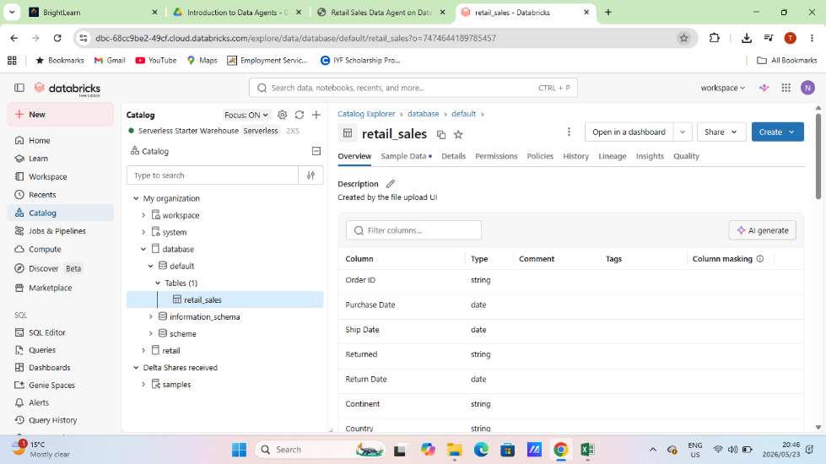

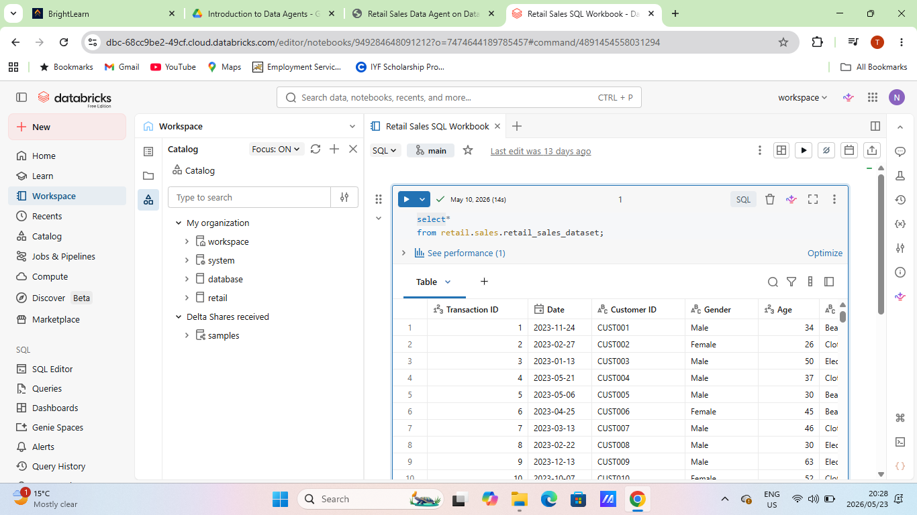

- AGENT INSTRUCTIONS
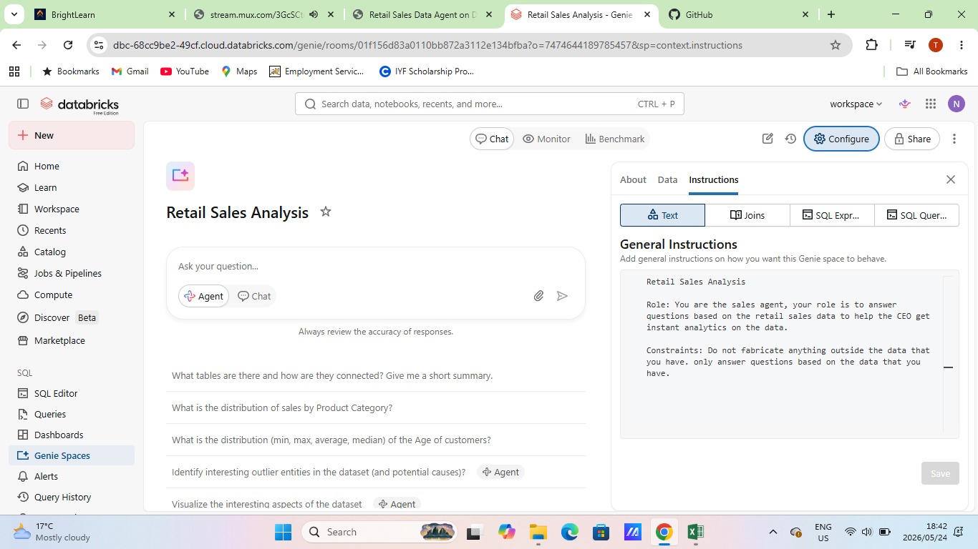

- 10 QUESTIONS
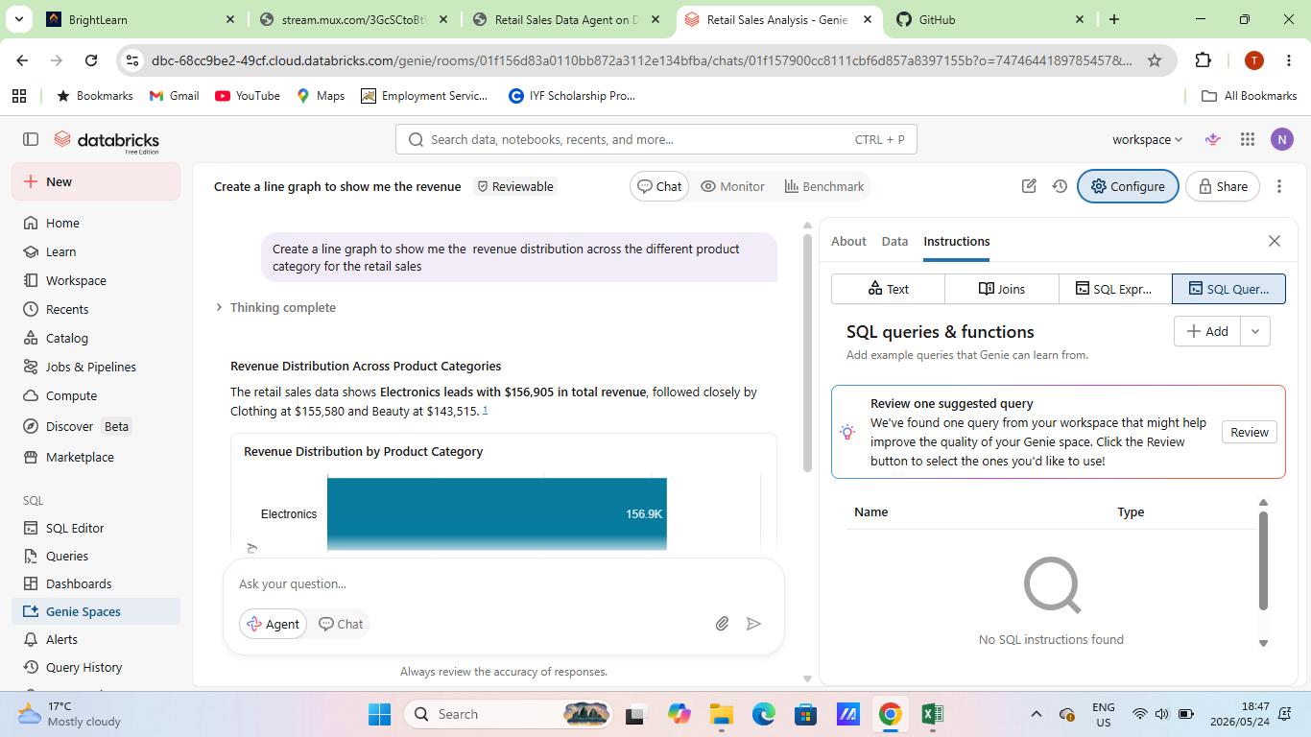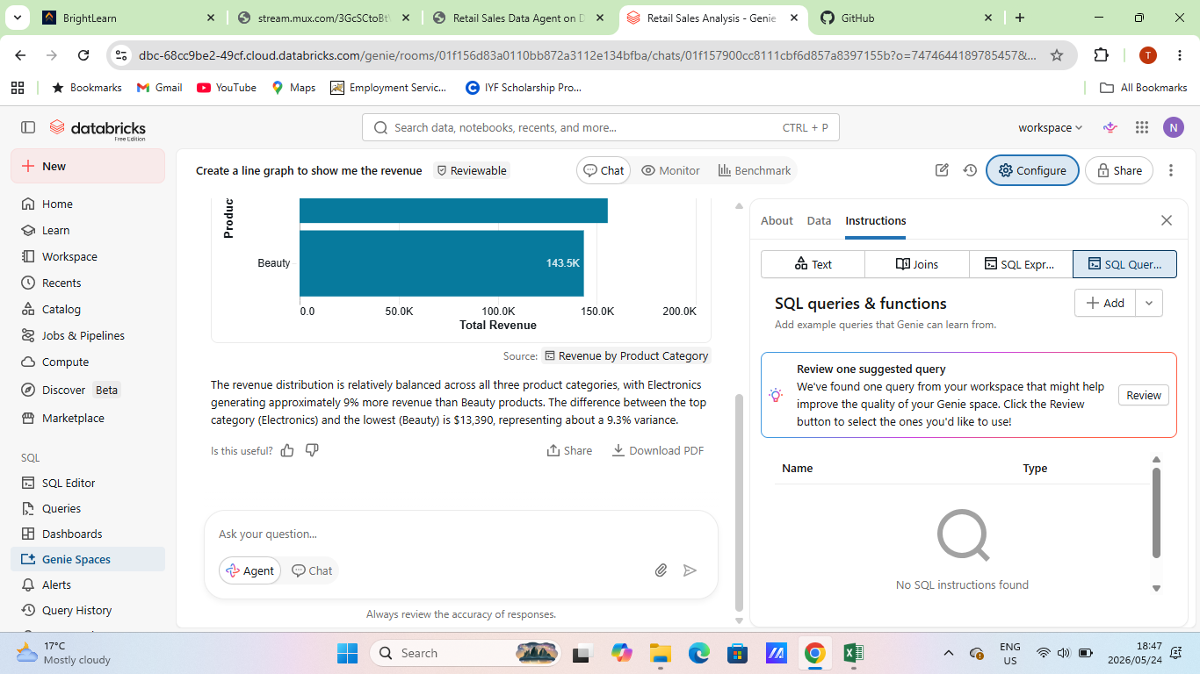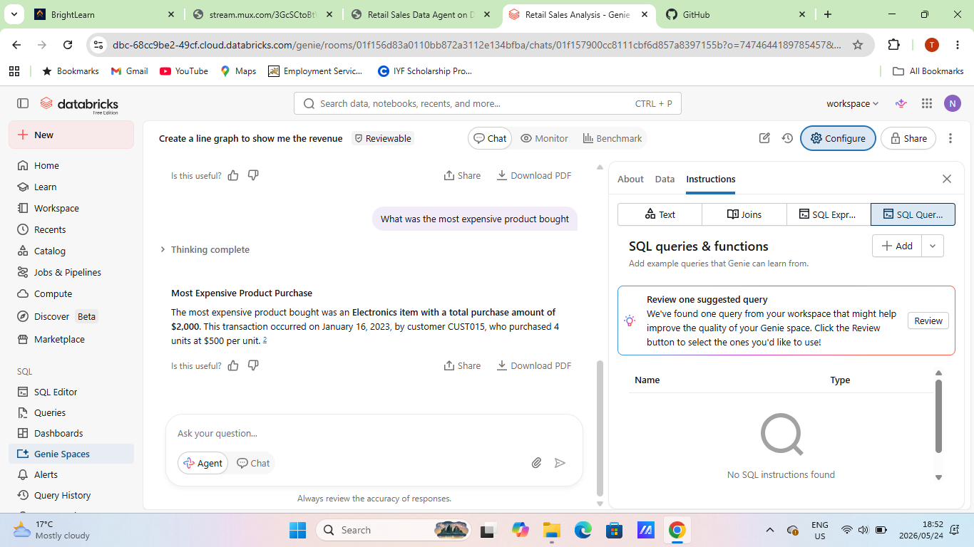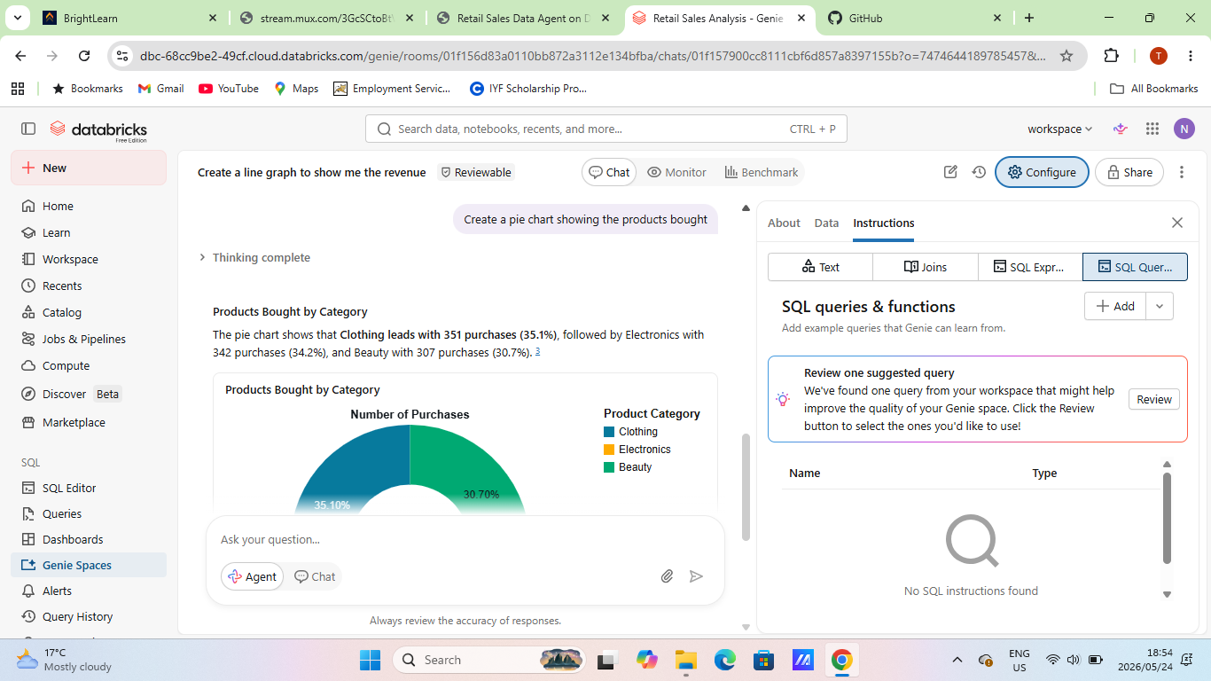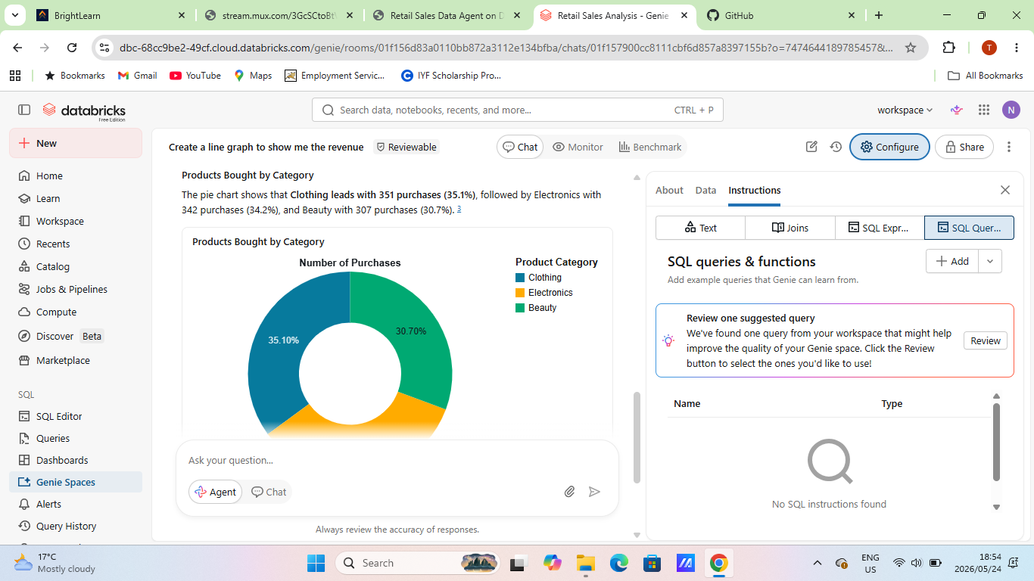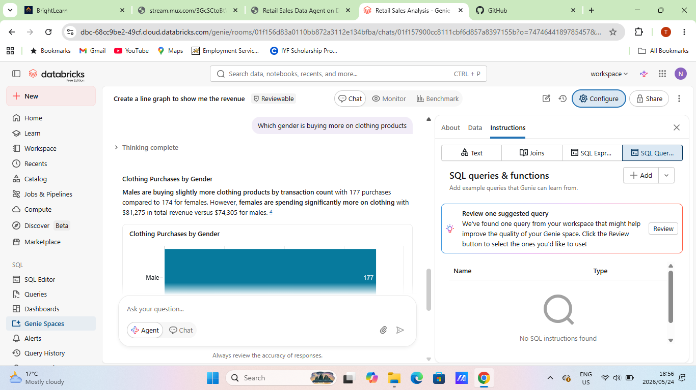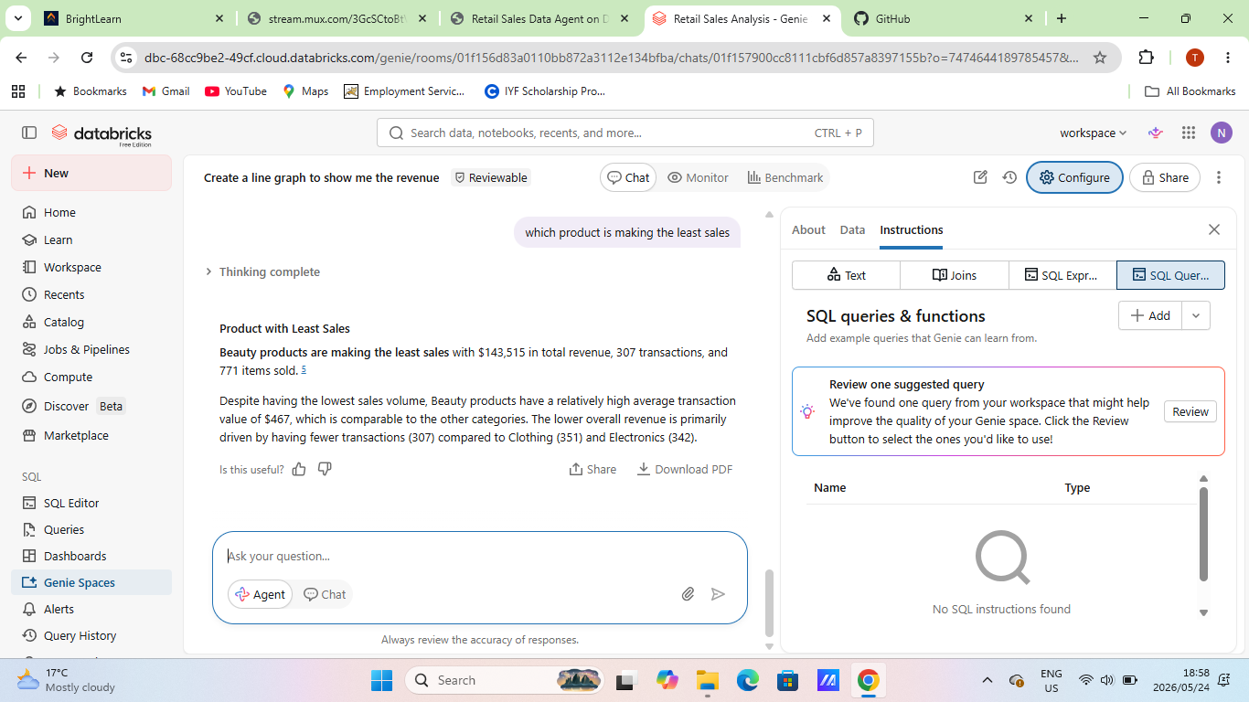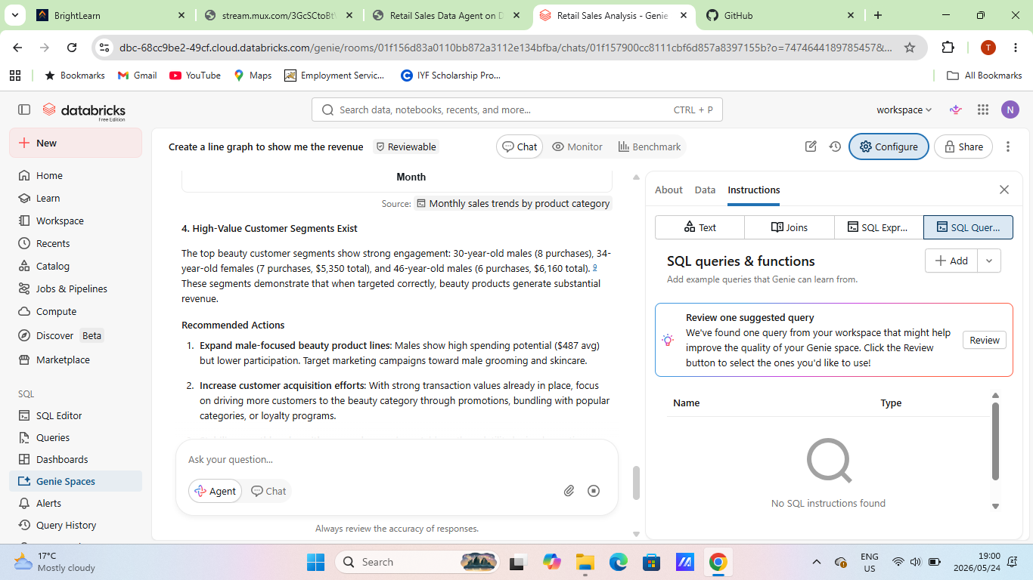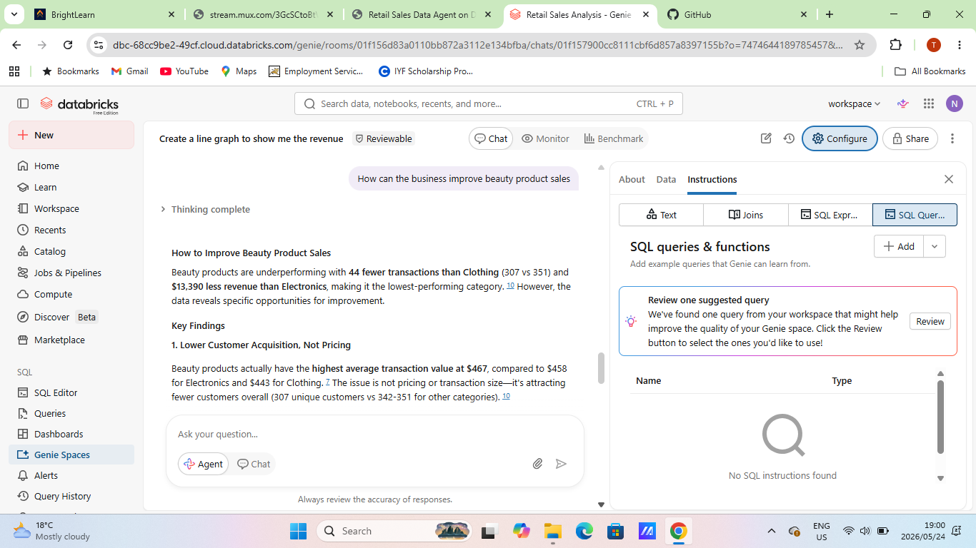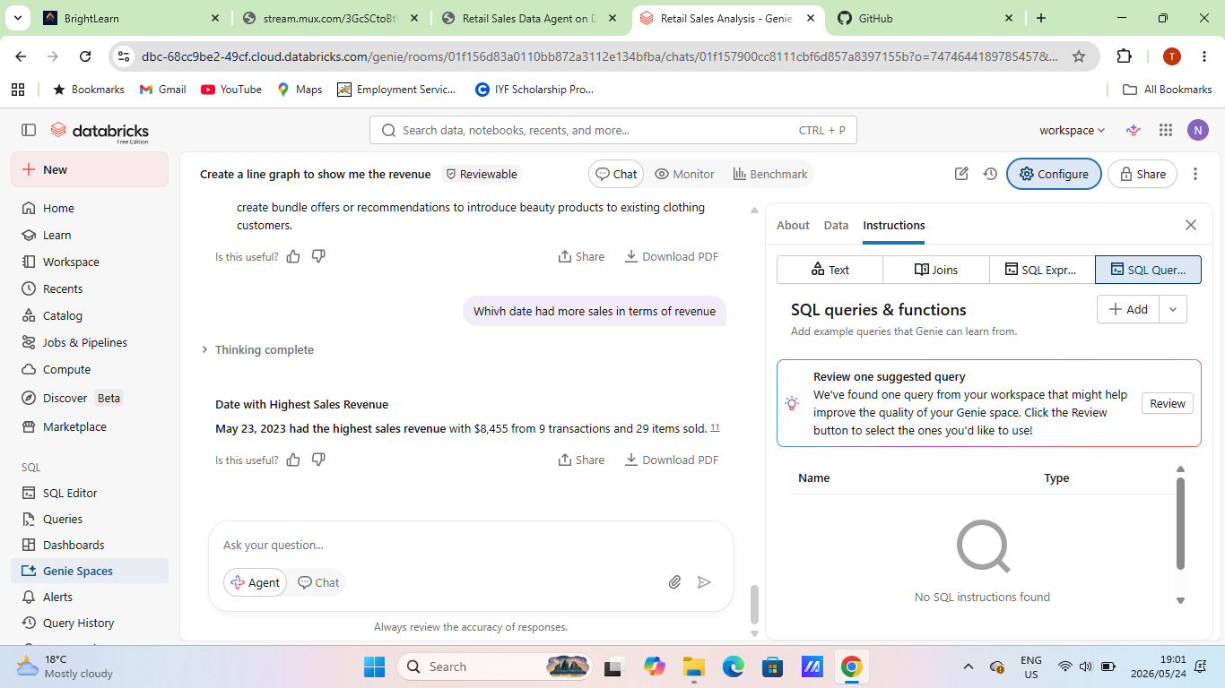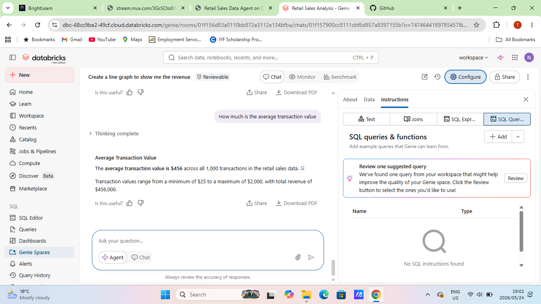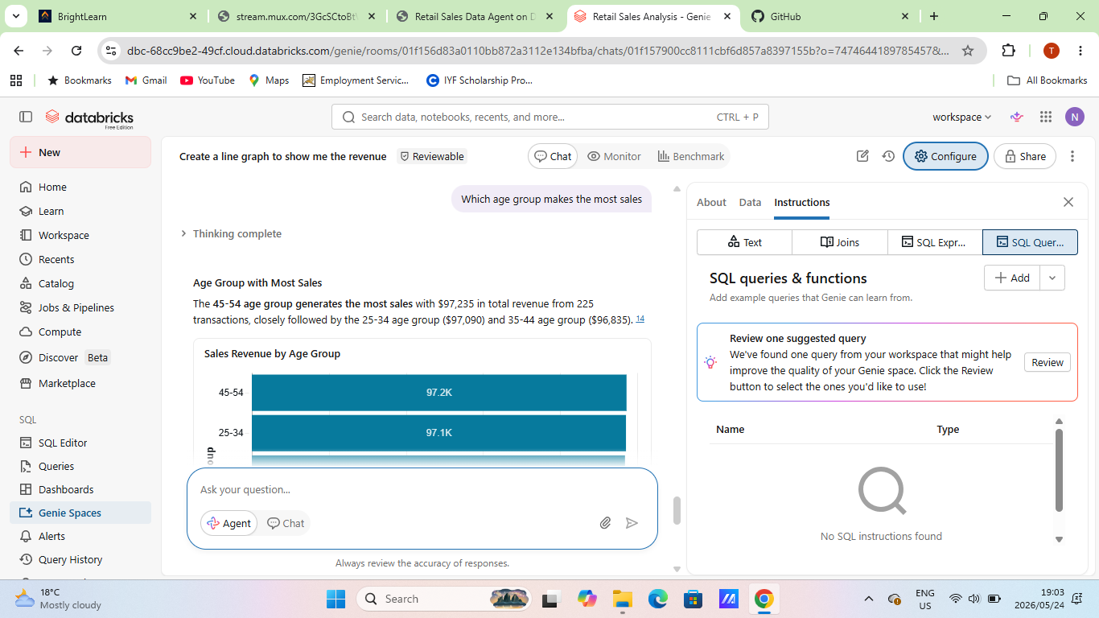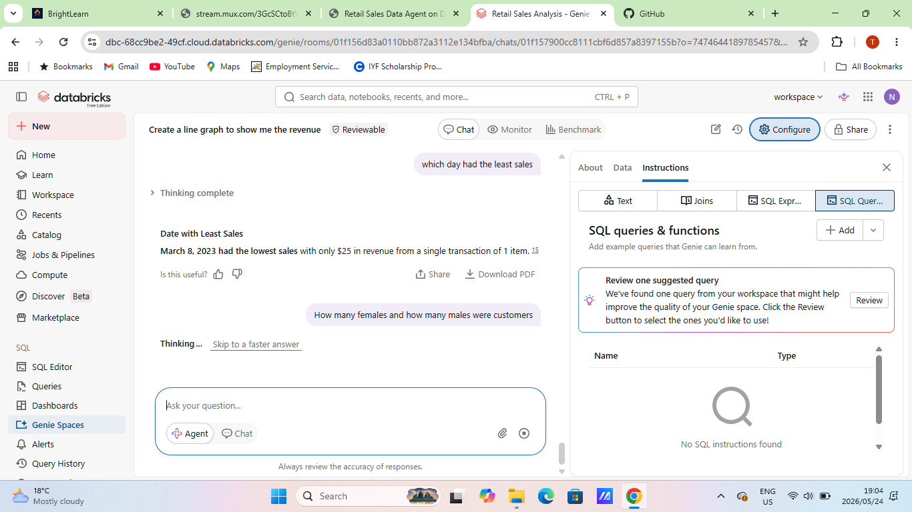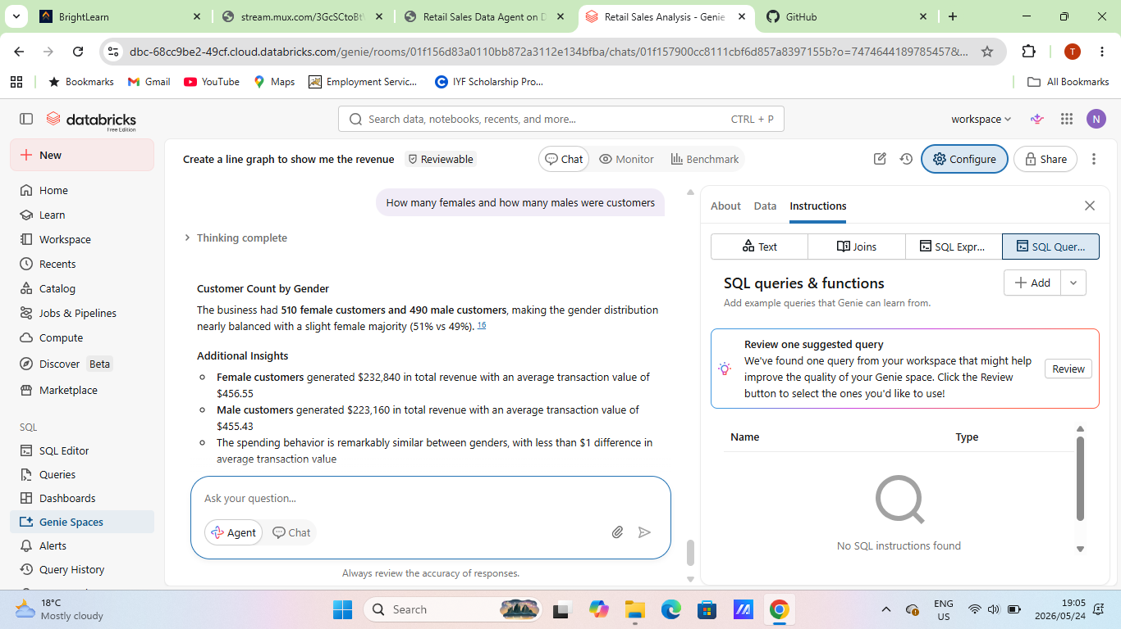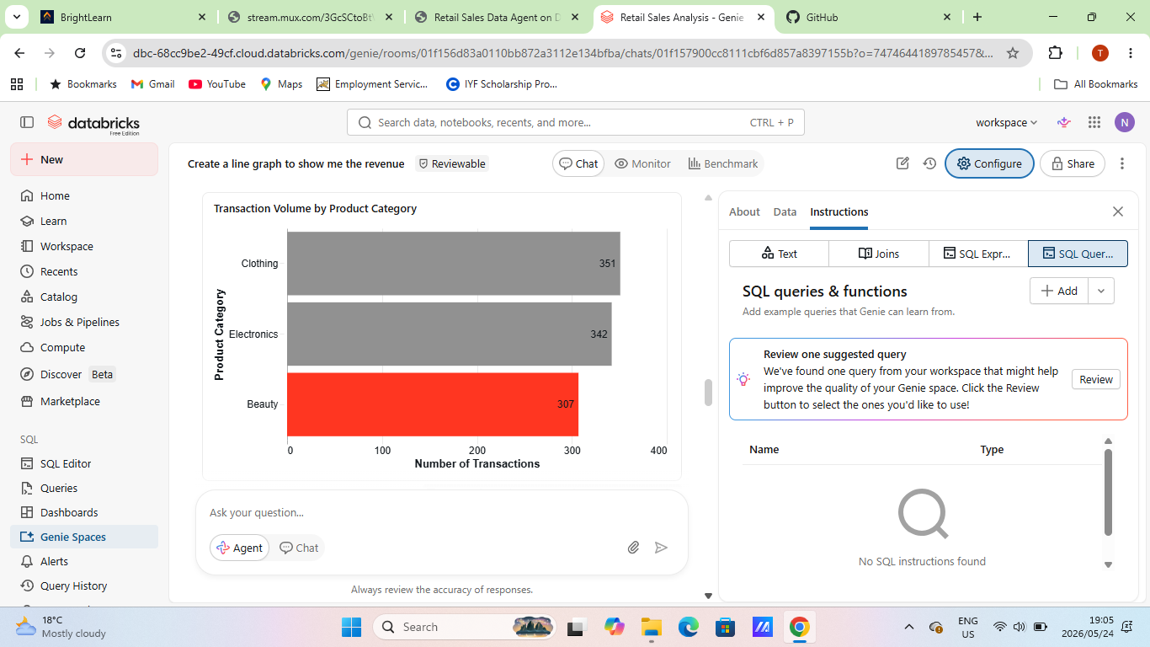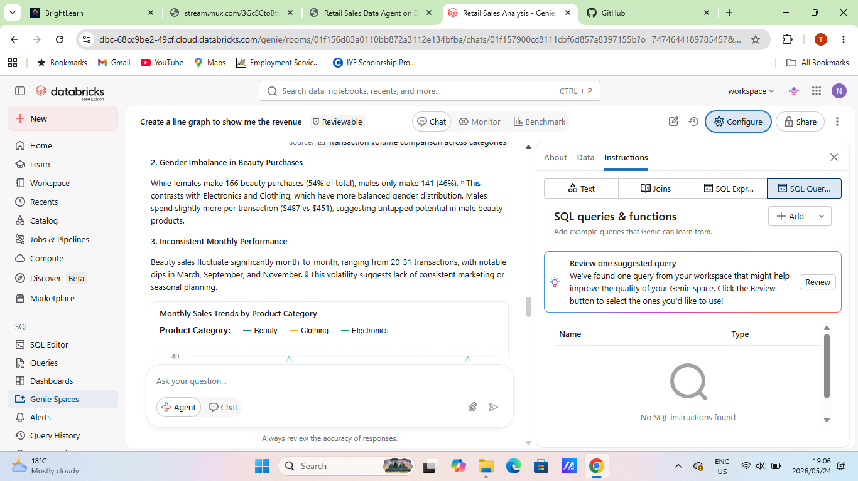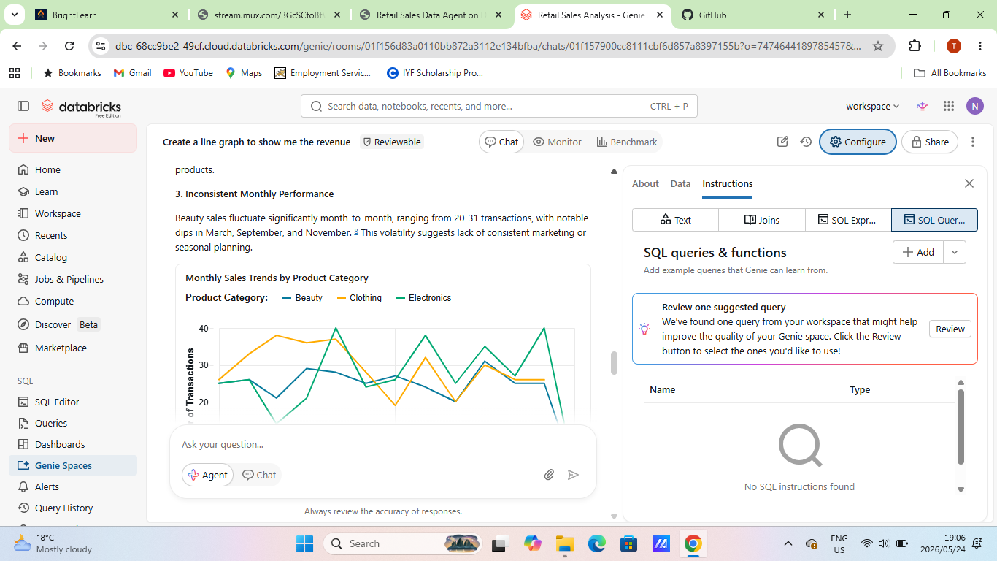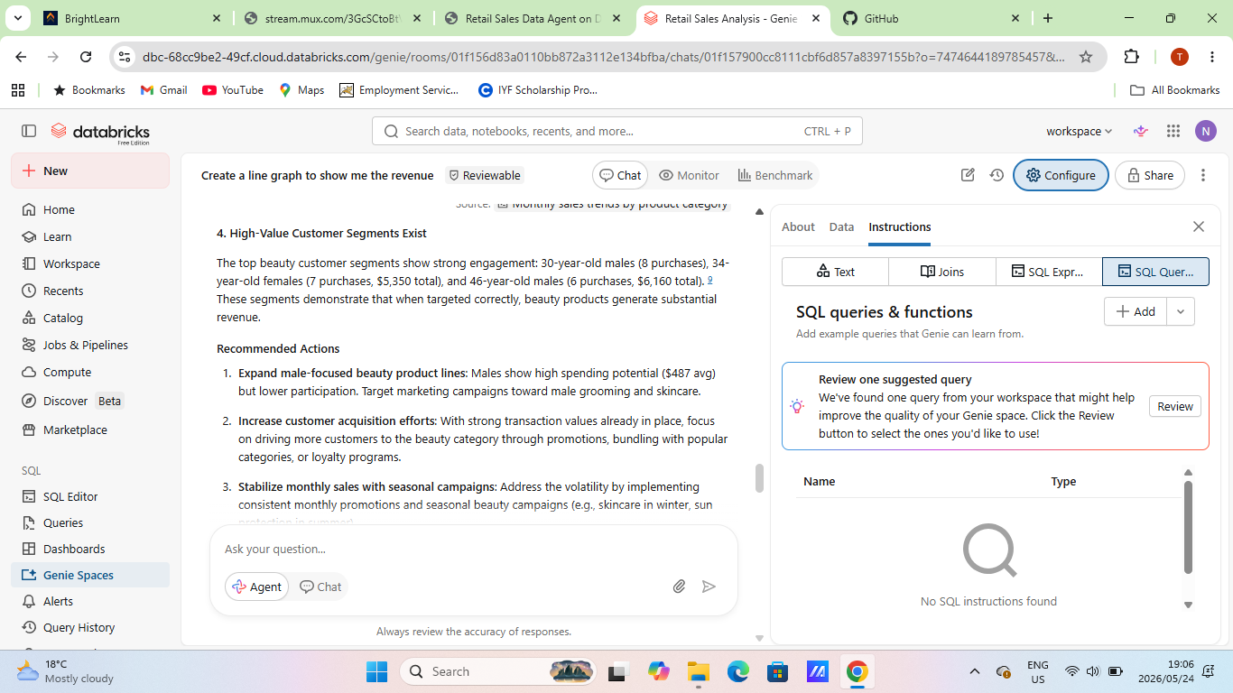

- VALIDATION OF 3 ANSWERS
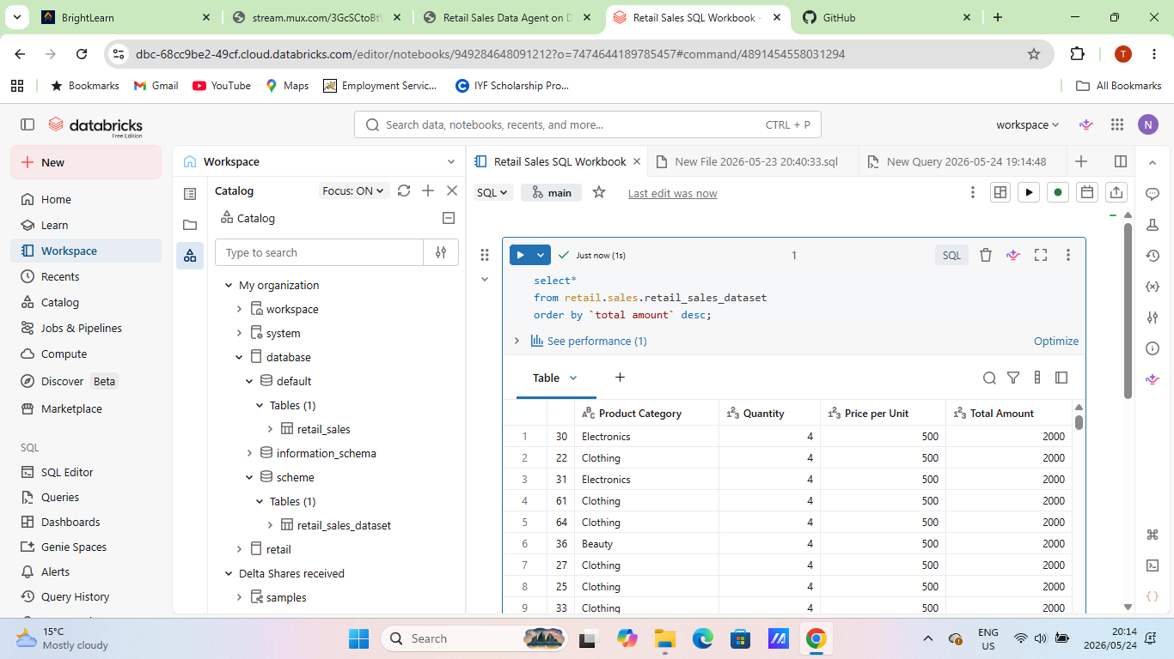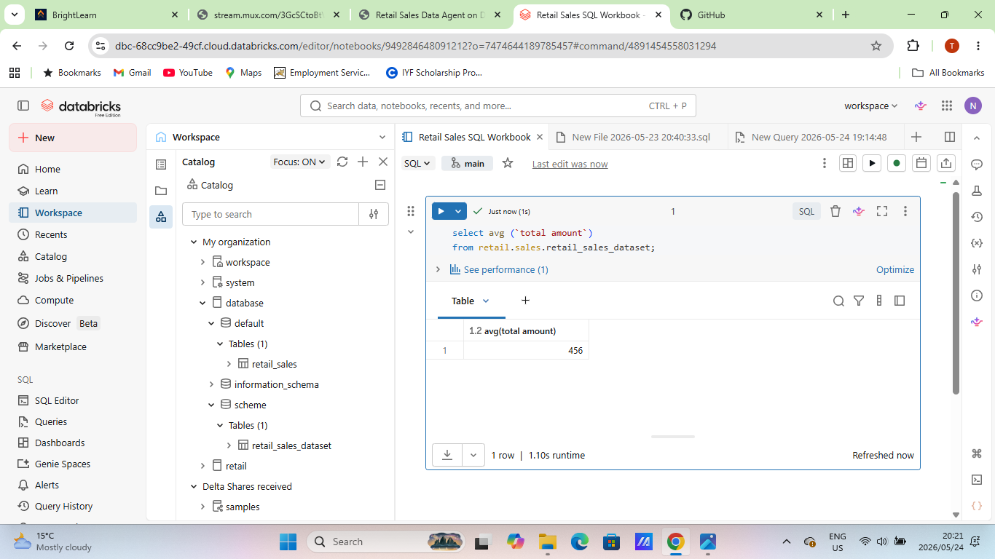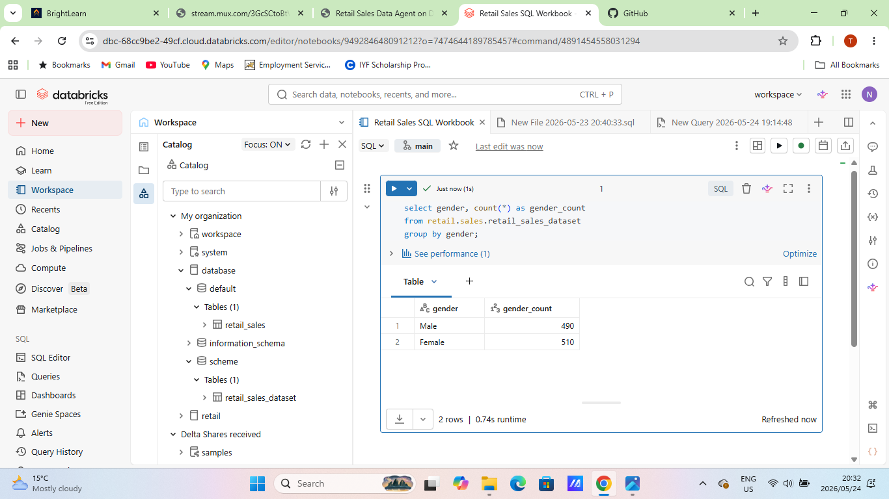
- KEY INSIGHTS
The shop generated $456,000 in total revenue from 1,000 transactions across 1,000 unique customers between January 2023 and January 2024, with an average transaction value of $456.
Electronics leads in revenue with $156,905 (34.4% of total), followed closely by Clothing at $155,580 (34.1%) and Beauty at $143,515 (31.5%). All three categories show relatively balanced performance with similar transaction counts (342, 351, and 307 respectively) and average transaction values around $450-$467.
Sales are evenly split between genders, with female customers generating $232,840 (51%) from 510 transactions and male customers generating $223,160 (49%) from 490 transactions. Both segments have nearly identical average transaction values of approximately $456. 4
Revenue shows significant monthly variation, with May 2023 being the strongest month at $53,150 (105 transactions), followed by December at $44,690 and February at $44,060. The weakest month was September at $23,620. The data shows one full year of operations with consistent activity throughout 2023.

- BUSINESS RECOMMENDATIONS
- Have fashion clothing campaigns on social media to target the youth group between 25-34 years of age.
- Extend weekend working hours to maximise profits as more customers are likely to visit stores over the weekend.
- Introduce midweek special to improve sales during the week.
- Introduce a buy 1 get 50% off on second product promotions on products that are making less sales.
- Introduce free delivery when a customer spends a certain amount of money to increase sales.
- Launch a loyalty point card where customers can get discounts when their points reach a certain amount.

- CONCLUSION
Creating a data agent worked as it helped me in understanding the data better. It brought more insight into some details of the data that I had missed.
At first, creating a data agent and asking the relevant questions was a bit challenging. However, at the end I got to be more comfortable in using data agent.
I would not change anything about this assignment or data agent. I found it to be very helpful and I am interested in learning more about it.

